
Webrecruit ATS
Feature Sheet

Preload Job Templates with Screening Questions
Job Templates are a fantastic way to make it even easier for Hiring Managers to raise Job Requisitions for you – simply select an appropriate template and have the form filled out for you.
To enhance the effectiveness of Job Templates, you can now have Screening Questions included within them. Pre-crafted and configured application forms will be automatically applied to your jobs when raised from templates, reducing or even completely removing the burden on the recruitment team.
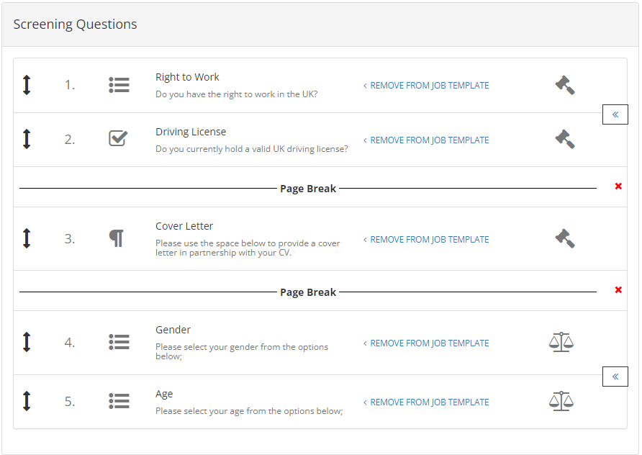

Closing Date placeholder in incomplete application reminders
When sending reminder emails to candidates about their incomplete applications, you can now include a placeholder for the closing date of the job in question, ensuring the candidate knows the deadline and encouraging timely action.
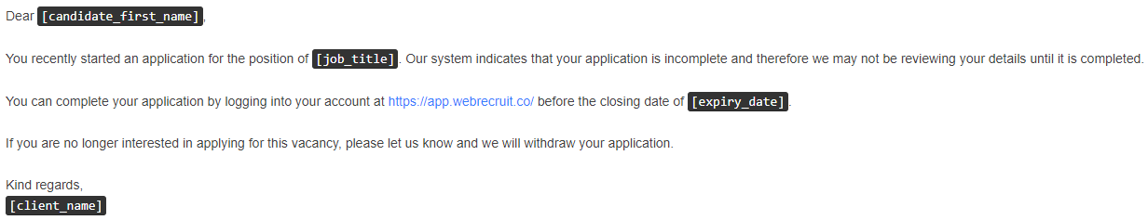

Improved help text
Throughout Webrecruit ATS, help text has been updated to improve clarity and usage, reducing errors and improving the overall user experience.

